YOUR TOTAL HEALTH
CH 1, Part 1
From GLENCOE HEALTH (2011)

BIG IDEA: Being in the best of _____________________________ throughout your life means making _____________________________ choices and practicing _____________________________ behaviors.
NEW VOCAB: (Define these words as they appear in the PowerPoint)
- ___________________________ -
- ___________________________ -
- ___________________________ -
- ___________________________ -
TAKE CHARGE OF YOUR HEALTH:
Main Idea - You are responsible for your own _____________________________.

You can develop the _____________________________and _____________________________you need to take charge of your health for a _____________________________.

Every day, you make _____________________________that shape your _____________________________.
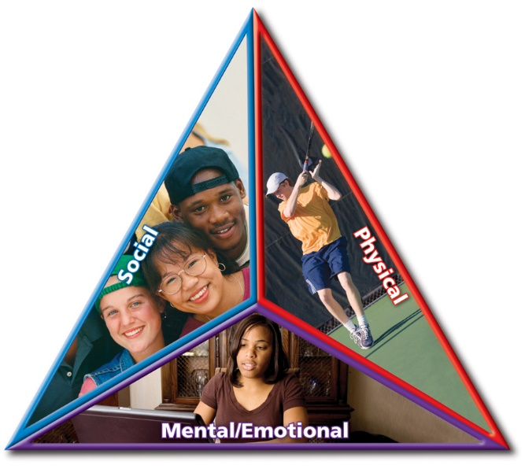
YOUR HEALTH TRIANGLE:
Main Idea - It’s important to balance your _____________________________, _____________________________/_____________________________, and _____________________________health.

Your health _____________________________is made up of three equally important areas.

PHYSICAL HEALTH:
Physical health is all about how well your body _____________________________.

Five Tips for Physical Health
- Get ________ to ________ hours of sleep each night.
- Eat nutritious _____________________________and drink _____________ cups of water each day.
- Engage in _____________________________ minutes of physical activity every day.
- Avoid the use of _____________________________, _____________________________, and other _____________________________.
- _____________________________daily, and _____________________________and brush your teeth every day.

MENTAL/EMOTIONAL HEALTH:
Mental/emotional health is about your feelings and thoughts. It’s a reflection of:
- How you feel about _____________________________.
- How you meet the _____________________________of your daily _____________________________.
- How you cope with the problems that occur in your _____________________________.

Characteristics of _____________________________ and _____________________________ Healthy People
- Enjoy challenges.
- Accept _____________________________ for their _____________________________.
- Have a sense of _____________________________ over their _____________________________.
- Can express their _____________________________ in appropriate ways.
- Usually can deal with life’s _____________________________ and _____________________________.
- Have a _____________________________ outlook.
- Make _____________________________ and _____________________________ decisions.

SPIRITUAL HEALTH:
Spiritual health involves having a feeling of _____________________________ and a sense of _____________________________.

SOCIAL HEALTH:
Social health is getting along with others.
Maintaining healthy _____________________________ is one way of caring for your _____________________________ health.

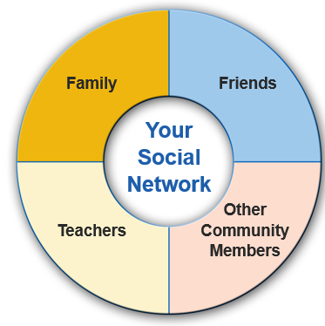
Tips for Maintaining Healthy Relationships to Care for Your Social Health
- _____________________________ and lend _____________________________ when needed.
- _____________________________ clearly and _____________________________ to others.
- Show _____________________________ and care for _____________________________ and others.

KEEPING A BALANCE
When your health triangle is _____________________________, you have a high degree of _____________________________.

Wellness comes from making _____________________________ decisions and practicing _____________________________ behaviors that are based on sound health _____________________________ and healthful _____________________________.

THE HEALTH CONTINUUM
Healthful _____________________________ will promote your _____________________________.

Your health at any moment can be seen as a point along a _____________________________, or sliding scale.

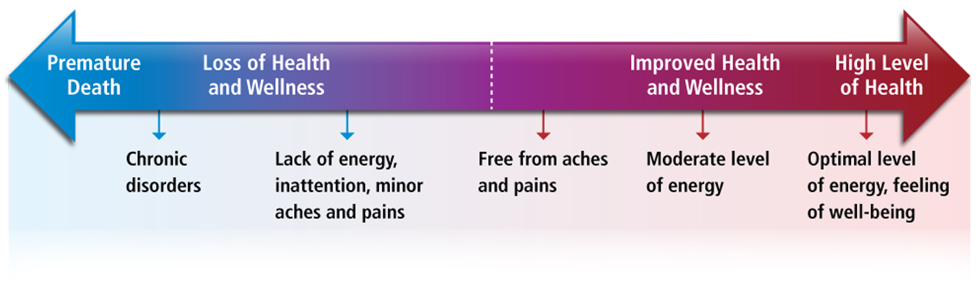
_____________________________ of all American adults live with a _____________________________ disease.

