YOUR TOTAL HEALTH
CH 1, Part 3
From GLENCOE HEALTH (2011)

BIG IDEA: Risk __________________________ can harm your __________________________, but there are steps you can take to __________________________ or __________________________ these risks.
NEW VOCAB:
Risk Behaviors -
Cumulative Risks –
Prevention –
Abstinence –
Lifestyle Factors –

Identifying Health Risks
__________________________ in risk behaviors can harm your __________________________.
You can __________________________ most __________________________ behaviors.
__________________________ risks will help you to __________________________ and __________________________ your health.

Recognizing Risk Behaviors
The Centers for Disease __________________________ and __________________________ (CDC) has identified six of the most significant risk behaviors for young people under age 24.
- ____________________________________
- ____________________________________
- ____________________________________
- ____________________________________
- ____________________________________
- ____________________________________

Risks and Consequences
__________________________ behaviors carry significant __________________________.
Both the __________________________ and __________________________ consequences can harm your health and well-being. Some risk behaviors can even be __________________________.
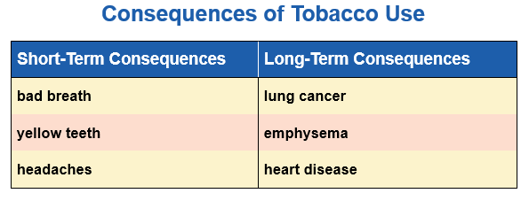
When you repeatedly __________________________ in certain risk behaviors you expose yourself to the effects of __________________________ risks.

Cumulative risks also __________________________ when several risk factors are __________________________.
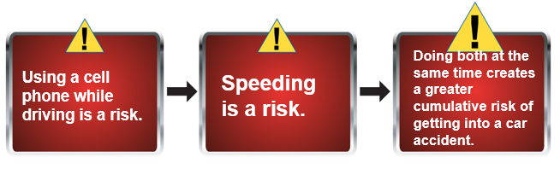
How to Avoid or Reduce Risks
You can take action to __________________________ your __________________________ to health risks.
You can __________________________ your health and __________________________ the possibility of risk by practicing __________________________ health behaviors.
Another way to __________________________ health risks is through __________________________.

How to Avoid or Reduce Risks
Choose __________________________ who avoid high-risk __________________________.

Abstaining from High-Risk Behaviors
One of the most __________________________ strategies for protecting your __________________________ is practicing __________________________.

Reasons to Practice Abstinence
- _________________________________________________________________________________
- _________________________________________________________________________________
- _________________________________________________________________________________
- _________________________________________________________________________________

Promoting Your Health
__________________________ participating in health-promoting behaviors will help you reach a __________________________ level of __________________________.

Understanding how your __________________________ impact your health will inspire you to __________________________ healthful __________________________ that can promote wellness and prevent disease.

Participating in positive __________________________ behaviors benefits all three sides of your __________________________.

Lifestyle Factors
__________________________ have found that positive lifestyle factors __________________________ people’s overall health, __________________________, and __________________________.
