YOUR TOTAL HEALTH
CH 1, Part 4
From GLENCOE HEALTH (2011)

BIG IDEA: Staying healthy takes knowledge, a plan, and practicing healthful behaviors.
NEW VOCAB:
Health Education –
Healthy People –
Health Disparities –
Health Literacy –

The Importance of Health Education
Individual, ___________________________, community, and national ___________________________, require planning and responsible ___________________________, on everyone’s part.
___________________________, the public is the key to creating a healthier ___________________________.

Health education can ___________________________, people to live ___________________________, and improve their quality of ___________________________.

The Nation’s Health Goals
The ___________________________, government has established national health goals and objectives through __________________________________________.

One of the goals of ____________________________________________ is to reduce the ___________________________ and ___________________________ rates in America.
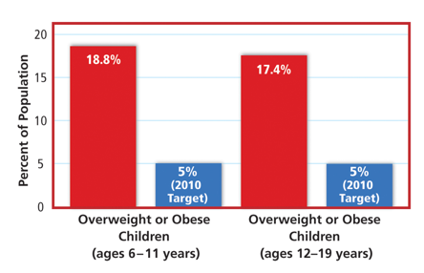
The nation has set a goal of ___________________________ these percentages to 5% of ______________________________________.

Goals of Healthy People
_____________________________________ established two general goals for the future:
- ___________________________ the quality and length of a healthy life for all Americans,
- ___________________________ health disparities that result from factors such as ___________________________, race, education, ___________________________, and location.
The health goals that are guiding early development of Healthy People 2020 include the following:
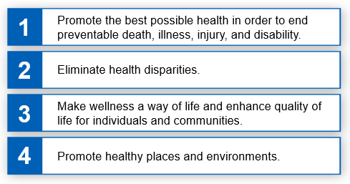
Becoming Health Literate
A health-___________________________ person knows how to find and use reliable ___________________________ information.
Every day people all across the ___________________________ have to make important ___________________________ that affect their ___________________________.

___________________________ who are informed know how to ___________________________ the information they need to make good ___________________________.

To become an informed ___________________________ who can make sound health ___________________________, one must know how to:
- _____________________________________________________________________________________
- _____________________________________________________________________________________
- _____________________________________________________________________________________
- _____________________________________________________________________________________

What You Can Do
In order to ___________________________ your ___________________________ and take steps to improve your ___________________________, you need to develop health ___________________________.

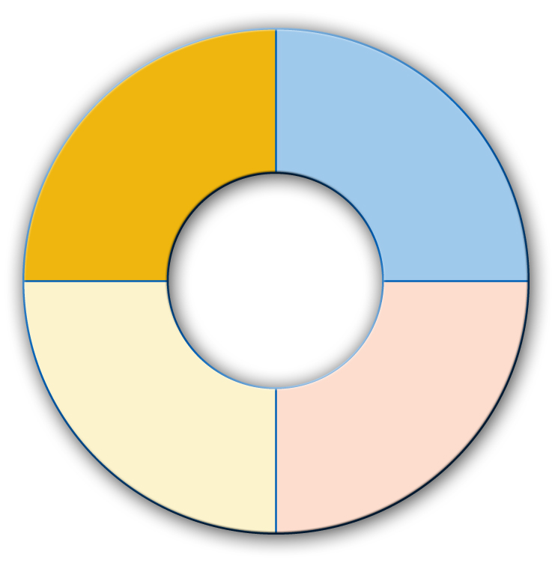
Qualities of a Health-Literate Individual

