THE ROLE OF MEDICINES
Chapter 19, Section 1
GLENCOE HEALTH (2011)

BIG IDEA:
Medicines are divided into and have different on different people.

NEW VOCAB
- Medicines
- Drugs
- Vaccine
- side effects
- additive interaction
- synergistic effect
- antagonistic interaction

Types of Medicines
Medicines are based on how they work in your body.
People use medicines to help their health when they are ill.
All medicines are drugs, but not all drugs are .
Drugs that are used to treat or prevent diseases or other conditions

Drugs are effective in treating illness when taken as by a physician or according to the label instructions.
Substances other than food that change the structure or function of the body or mind

Four Categories of Medicines that Treat or Prevent Illness
- Medicines that help prevent disease
- Medicines that fight pathogens
- Medicines that relieve pain and other symptoms
- Medicines that manage chronic conditions, help maintain or restore health, and regulate body’s systems

Preventing Disease
Today, we have medicines that prevent disease. About percent of children receive vaccines.
A preparation that prevents a person from contracting a specific disease

Vaccines
Vaccines contain weakened or dead that cause the disease.
When injected into your body, the vaccine produces that fight those pathogens.
Your body also produces cells that recall how to make these antibodies.
This provides you with long-lasting against these specific pathogens.
Your body also produces memory cells that how to make these antibodies.
This provides you with long-lasting protection against these specific pathogens.

Antitoxins
Antitoxins prevent disease and the effects of toxins.
Antitoxins fight the bacteria that produce substances to the body.
Fighting Pathogens
Medicines can also help your body fight the that cause illness

Antibiotics
Antibiotics are a class of drug that destroy disease-causing microorganisms, called

Antibiotics work either by harmful bacteria in the body or by
bacteria from reproducing.
The bacteria that antibiotics kill have to the drug over time.
Bacteria can develop a to antibiotics when antibiotics are overused.
If you do not taking all of a prescription, you may not kill all of the bacteria.
The remaining bacteria may develop a resistance, or , to treatment.
is a bacterial infection that is treated with antibiotics prescribed by a doctor.
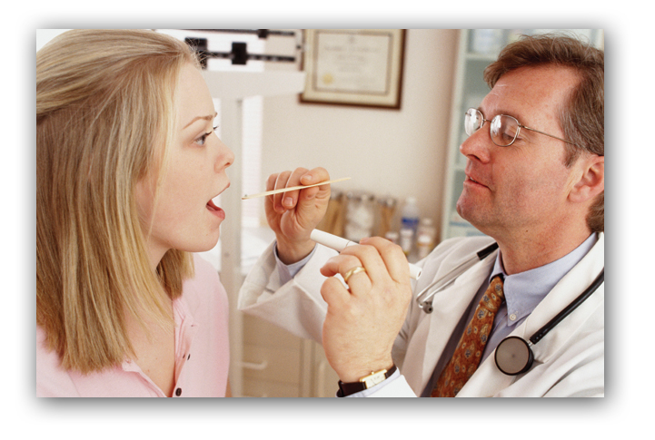

Antivirals and Antifungals
Antiviral drugs are used to treat some illnesses, such as the flu. They suppress the virus, but do not kill it.
Like bacteria, viruses can develop a to medications.
Fungi are another type of that can infect the body.
can suppress or kill fungus cells, such as athlete’s foot and ringworm.

Relieving Pain
The most commonly used medicines are , or pain relievers.
Aspirin is used to relieve pain and reduce fever. Other analgesics fight
, or redness, swelling, and pain.
Children who take aspirin when they have a fever risk developing , a potentially life-threatening illness of the brain and liver.
For that reason, should not be given to anyone under the age of 20 unless directed by a health care professional.

Pain Reliever Dependence
Certain types of medicines that relieve pain can be .
These medicines, usually called , require a doctor’s prescription.

Managing Chronic Conditions
Some medicines are used to treat conditions.
These medicines or restore health, and offer people with chronic diseases a higher level of .

Allergy Medicines
reduce allergy symptoms such as sneezing, itchy or watery eyes, and a runny nose.
They block the chemicals released by the immune system that cause an response.

Regulate the amount of sugar in the blood=

Control symptoms and prevent attacks=

Regulate functions of the cardiovascular system=

Antidepressant and Antipsychotic Medicines
Medications can also help people suffering from
These medicines can help regulate brain , or stabilize moods.

Cancer Treatment Medicines
Some medicines are used to treat .
These medicines can reduce cell growth and help stop the spread of cancer cells.

Taking Medications
Medicines enter the body in a of ways.
Factors that determine how a medicine is taken include what the medicine is used for, and how it will most quickly and help a person.

Taken by mouth
Applied to the skin
Delivered in a fine mist or powder
Delivered through a shot

Medications help many people with such as asthma and diabetes live active, normal lives.

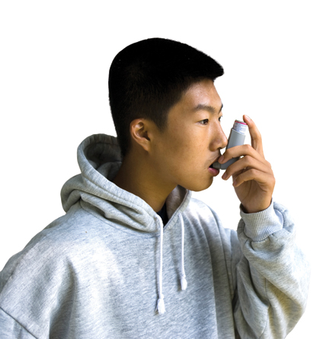
Reactions to Medications
The of medicine depends on many factors.
Medicines can have a of effects.
Some side effects may be mild, such as drowsiness, but others may be more severe, and can even cause
Reactions to medicine other than the one intended
Medicine labels include important information about possible and interactions.

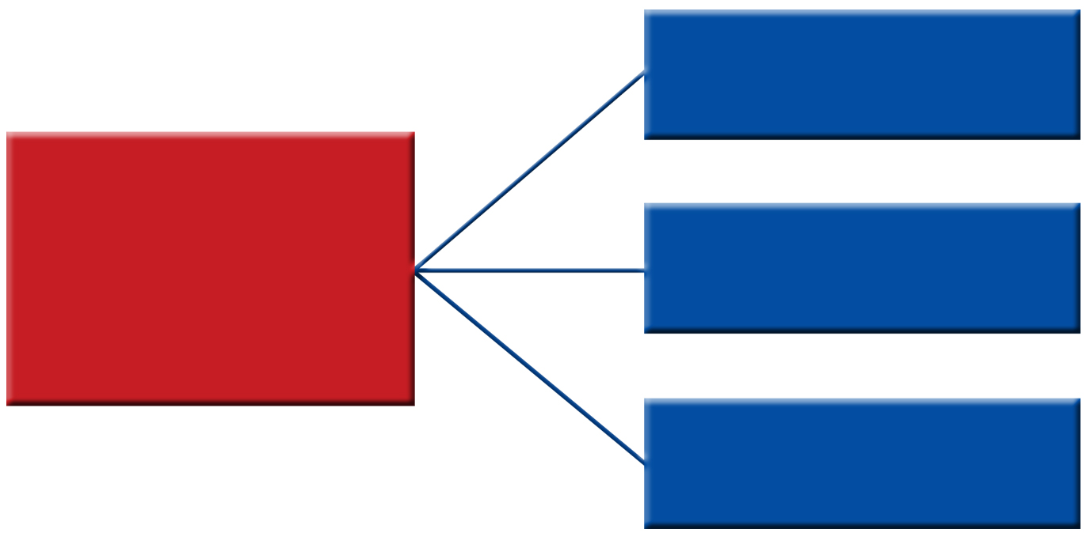

One example of an additive interaction is when an anti-inflammatory and a muscle relaxant are prescribed to treat joint pain.
When medicines work together in a positive way

When one medicine increases the strength of another it is a synergistic effect.
The interaction of two or more medicines that results in a greater effect than when each medicine is taken alone
When one medicine the strength of another it is an antagonistic interaction.
The effect of one medicine is canceled or reduced when taken with another medicine

Tolerance and Withdrawal
is a condition in which the body becomes used to the effect of a medicine.
occurs when a person stops using a medicine on which he or she has become physiologically dependent.

