USING MEDICINES SAFELY
Chapter 19, Lesson 2
GLENCOE HEALTH (2011)

BIG IDEA:
Medicines are only safe if they are used for the intended and according to the directions on the label.

NEW VOCAB:
- prescription medicines
- over-the-counter (OTC) medicines
- medicine misuse
- medicine abuse
- drug overdose

Standards for Medicines
Medicines are to make them safe.
All new medicines in the United States must meet set by the Food and Drug Administration (FDA).
Drug manufacturers test new medicines according to FDA .
That includes completing at least three clinical trials in which the drug is tested on
volunteers.
Sometimes, if a drug hasn’t yet completed clinical trials but is thought to be
, people with life-threatening illnesses are to use the drug.
This usage is referred to as
The FDA does not regulate and supplements.
Even supplements made from natural compounds can have side effects or interactions.
Prescription Medicines
A licensed pharmacist prescription medicines.
Medicines that are dispensed only with the written approval of a licensed physician or nurse-practitioner

Over-the-Counter (OTC) Medicines
The FDA considers over-the-counter (OTC) medicines to be safe if they are used as the label .
Medicines you can buy without a doctor’s prescription

Medicine Labels
Ingredient that treats condition, including amount per unit
Substances added to the product that do not help treat the condition, such as flavor and color
Conditions or symptoms treated by the product
The date you should no longer use the medicine
Product category and what the product is supposed to do, such as antacid
Side effects, interactions, when to talk to a doctor, when not to take the product, keep out of reach of children
Other information may be printed on the opposite side of the label

Prescription medicine labels also include this information
- Special instructions for taking the medicine
- The prescribing doctor’s name
- The patient’s name
- The pharmacy’s name and address
- The date the prescription was filled
- The prescription number
- Whether refills are allowed

This is an example of a medicine label for an over-the-counter (OTC) medicine.
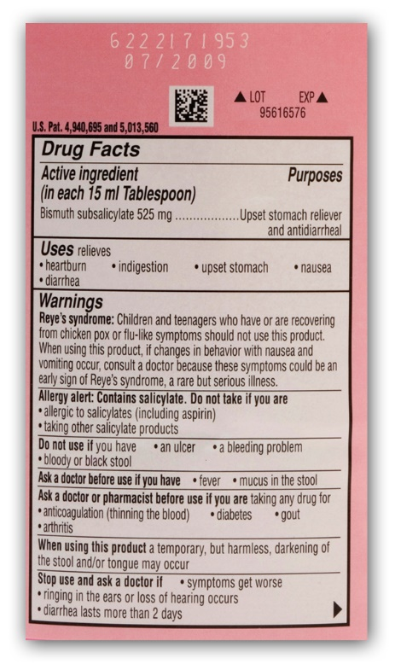

Medicine Misuse
Taking medicines or without following the label instructions is dangerous
Medicine misuse can the user from getting the full benefit of the medicine.
Medicine misuse can have serious health .
Using a medicine in ways other than the intended use
Examples of Medicine Misuse
- Failing to follow the instructions on or in the package
- Giving a prescription medicine to a person for whom it was not prescribed, or taking another person’s medicine
- Taking too much or too little of a medicine
- Taking a medicine for a longer or shorter period than prescribed or recommended
- Discontinuing use of a medicine without informing your health care provider
- Mixing medicines without the knowledge or approval of your health care provider

Medicine abuse is dangerous and
Intentionally taking medications for non-medical reasons

! Don’t use drugs to lose weight. !
! Don’t use drugs to stay awake while studying. !
! Don’t use drugs to fit in with peers !

One danger of medicine misuse is drug
A strong, sometimes fatal reaction to taking a large amount of a drug

