BUILDING YOUR HEALTH
Chapter 2, Section 1
GLENCOE HEALTH

BIG IDEA: You can develop skills that will help you manage your health throughout your life

NEW VOCAB:
- health skills
- interpersonal communication
- refusal skills
- conflict resolution
- stress
- stress management skills
- advocacy

Learning Health Skills
help you manage your health
Health skills are also called , because once you’ve developed these skills, you can use them throughout your life to stay healthy.

You will have opportunities to practice throughout the rest of the book.
Health Skills:
Specific tools and strategies to , , and all aspects of your health

COMMUNICATION SKILLS
Good is a vital health skill
Communication is more than just .

Three health skills— , , and —deal with how you give and receive information.
Interpersonal communication:
The exchange , , and between two or more people

Communication helps you build strong with others. It involves:
- your words and expressions carefully to clearly say what you really mean.
- closely to others.

Developing strong helps you say no firmly, respectfully, and .

skills can help people resolve problems in ways that are agreeable to everyone involved.

Use reliable sources of health information
Knowing how to and health information will help you make decisions that benefit your .
To decide whether health information is , determine the of the group or individual sharing the information.

ANALYZING INFLUENCES
Understanding what you helps you to make more choices.

INFLUENCES ON YOUR HEALTH:
1. 5.
2. 6.
3. 7.
4. 8.

These positive behaviors can contribute to all aspects of your health.
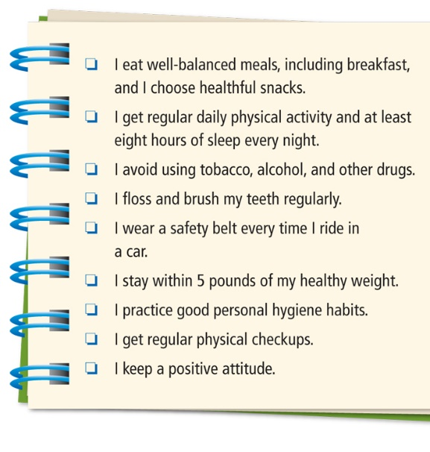
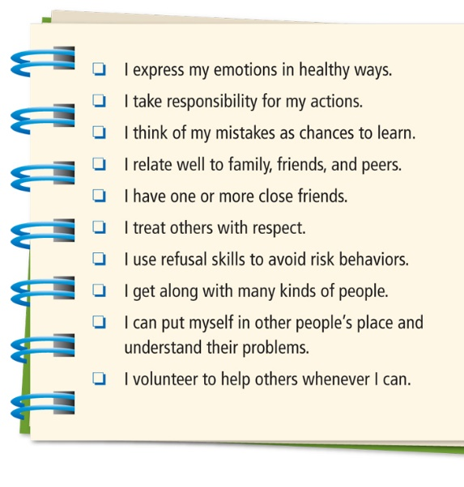

Practicing healthy will protect your health.
When you practice healthy behaviors and manage , you act in ways that your health and promote your well-being.
means taking charge of your own health. These are self-management skills:
-
-

, , and managing efficiently are some effective ways to manage stress.
-the reaction of the body and mind to everyday challenges and demands

Stress is a normal part of life, but too much unrelieved stress can lead to illnesses. That’s why it’s important to learn .
Skills that help you reduce and manage stress in your life are called

allows you to share health knowledge and promote healthful behaviors.
means taking action to influence others to address a health-related concern or to support a health-related belief

