BEING A HEALTH LITERATE CONSUMER
Chapter 2, Section 3
GLENCOE HEALTH

BIG IDEA: A health literate consumer carefully health products and services.

NEW VOCAB:
- health consumer
- advertising
- comparison shopping
- warranty

TAKE CHARGE OF YOUR HEALTH
You can learn to make good choices.
Being a smart shopper is especially important when it comes to making choices about and

MAKING INFORMED CHOICES
It’s up to you, as a , to make informed buying decisions.
-someone who purchases or uses health products or services
Probably the most important influence you need to be aware of as a consumer is .
-a written or spoken media message designed to interest consumers in purchasing a product or service
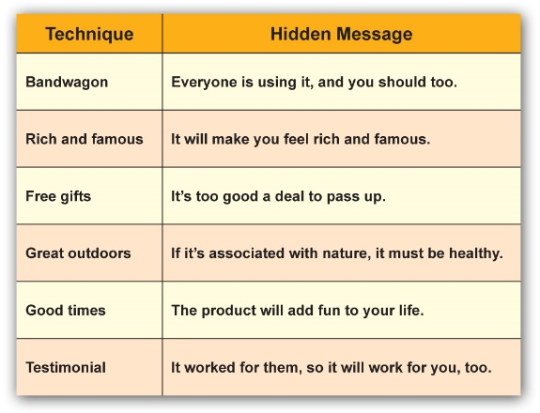Being a health-literate consumer means being aware of and knowing how to evaluate in advertising so you make purchasing decisions.

EVALUATING PRODUCTS
There are two effective ways to sharpen your consumer skills when buying health products:
1-
2-

PRODUCT LABELS
Labels give you important information about what a product contains.
1.
2.
3.
4.
5.
6.
7.

COMPARISON SHOPPING
A second great tool for smart health consumers is .
-judging the benefits of different products by comparing several factors, such as quality, features, and cost
Here are some criteria to consider when judging health products and services:
1.
2.
3.
4.
5.
6.

Before buying an expensive product, ask about the .
-a company’s or a store’s written agreement to repair a product or refund your money if the product doesn’t function properly

EVALUATING HEALTH INFORMATION AND SERVICES
To evaluate health information or services, ask yourself these questions:
- Does this information come from a ?
- Does the service come from a ?
- If the source is a Web site, who pays for the site? Is it a organization? What is the of the site?

