THE HEALTH RISKS OF TOBACCO USE
Chapter 20, Section 1
GLENCOE HEALTH (2011)

BIG IDEA:
The chemicals in all tobacco products harm the body.

NEW VOCAB:
- addictive drug
- nicotine
- stimulant
- carcinogen
- tar
- carbon monoxide
- smokeless tobacco
- leukoplakia

Health Risks of Tobacco Use
All forms of tobacco contain chemicals that are dangerous to your
Tobacco use is the leading cause of preventable and in the United States.
form of tobacco use, such as smoking, chewing, or dipping tobacco, can cause health problems.
Smoking has been to lung disease, cancers, and heart disease.
About of adult smokers began the habit as teenagers.

It’s easier to tobacco use rather than later.

Nicotine
Tobacco users have difficulty quitting because tobacco contains an addictive drug.
A substance that causes physiological or psychological dependence
All tobacco products contain nicotine.
The addictive drug found in tobacco leaves
Nicotine is a stimulant that raises blood pressure and increases the heart rate.
A drug that increases the action of the central nervous system, the heart, and other organs

Poisonous Substances in Tobacco Smoke
Tobacco is an addictive and drug and a carcinogen.
A cancer-causing substance

Tar
Cigarette smoke contains tar.
A thick, sticky, dark fluid produced when tobacco burns

Tar damages a smoker’s respiratory system by
- paralyzing and destroying cilia
- destroying the alveoli
- damaging lung tissue

Carbon Monoxide
Carbon monoxide is also in cigarette smoke. It deprives the body’s tissues and cells of oxygen.
A colorless, odorless, and poisonous gas

Pipes, Cigars, and Smokeless Tobacco
No tobacco product is to use.
The dangers of tobacco use are not limited to smoking cigarettes.
Cigarette do not protect smokers from more than 50 carcinogens, including cyanide and arsenic, which are in tobacco products.
The smoke from pipes and cigars also causes serious health consequences.
Cigars contain significantly more and produce more tar and carbon monoxide than cigarettes.
The harmful chemicals of smokeless tobacco are into the body at levels up to three times the amount of a single cigarette.
Tobacco that is sniffed through the nose, held in the mouth, or chewed
Using smokeless tobacco also the sensitive tissues of the mouth, causing leukoplakia.
Thickened, white, leathery-looking spots on the inside of the mouth that can develop into oral cancer

Harmful Effects of Tobacco Use
Tobacco use causes both short-term and long-term to your body.
Health officials have warned the public about the dangers of tobacco use for several
.

Brain chemistry changes.
Short-Term Effects
Respiration and heart rate increase.
Bad breath, yellowed teeth, and smelly hair, skin, and clothes.
Taste buds are dulled and appetite is reduced.

Long-Term Effects

Chronic bronchitis

Emphysema
A weakened immune system
Coronary heart disease and stroke
Lung cancer

Smokers cause severe damage to their lungs.

LONG TERM EFFECTS

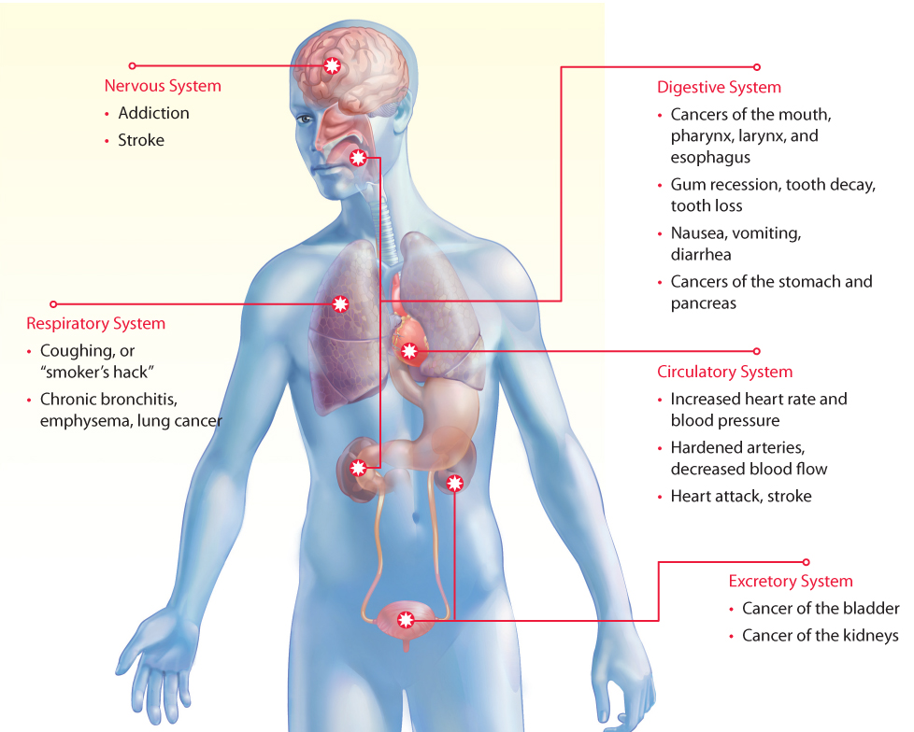

Other Consequences of Tobacco Use
As well as health risks, tobacco use is costly.
Making the decision to avoid the use of tobacco products will safeguard your health.

Tobacco-related illnesses cost the United States about $165 billion each year.

A person smoking one pack of cigarettes a day will spend about $1,500 a year on the habit.

Selling tobacco products to minors is illegal. Using tobacco at school can lead to suspension or expulsion.

