CHOOSING TO LIVE TOBACCO FREE
Chapter 20, Section 2
GLENCOE HEALTH (2011)

BIG IDEA:
Avoiding tobacco use will bring health benefits.

NEW VOCAB:
- nicotine withdrawal
- nicotine substitute
- tobacco cessation program

Teens and Tobacco
Fewer are starting to use tobacco
Knowing the health risks of tobacco use helps teens make the decision to stay tobacco-free.

Why Some Teens Use Tobacco
FALSE BELIEF
- Smoking helps control weight
- Smoking helps cope with stress
THE TRUTH
- Smoking reduces the capacity for physical activity, so it may lead to weight gain.
- Nicotine addiction and tobacco-related health problems increase stress.
Others believe that smoking will make them seem and independent.
Media images may convince teens that tobacco use is

Reduced Tobacco Use Among Teens
The CDC reports that of high school students nationwide do not smoke.
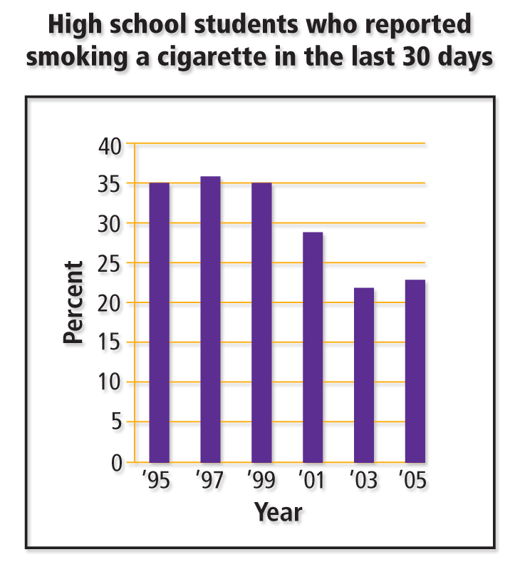

Reduced Tobacco Use Among Teens
Reasons Teens Are Smoking Less
1.
2.
3.
4.
5.

Teens who choose a tobacco-free lifestyle will feel and better than teens who use tobacco.

Benefits of Living Tobacco-Free
A tobacco-free lifestyle has many
The best way to avoid the negative consequences of tobacco use is to start using tobacco products.

You will have better health and fewer health risks.
You will have less stress and a sense of freedom.
You will look and feel better.

Strategies for Avoiding Tobacco
Use these strategies to stick to your decision to live tobacco-free:
1.
2.
3.
4.

Quitting Tobacco Use
There are good reasons for quitting tobacco use.
- Health care professionals can help tobacco users find the resources they need to successfully quit using tobacco.
- Teens who use tobacco give these reasons for quitting
- They begin to have health problems, such as asthma, coughing, or respiratory infections.
- They realize the high cost of tobacco or find it difficult to purchase tobacco products if they are under 18.
- They realize that using tobacco can lead to other risky behaviors, such as the use of alcohol and other drugs.
- They understand the damaging effects of secondhand smoke and do not want to harm others.
- They feel more powerful because they are not controlled by an addiction to nicotine.

Ending the Addiction Cycle
Symptoms of nicotine withdrawal include irritability, difficulty concentrating, anxiety, sleep disturbances, and for tobacco.
The process that occurs in the body when nicotine, an addictive drug, is no longer used
Smoking while using nicotine substitutes is dangerous due to increased nicotine
.
Products that deliver small amounts of nicotine into the user’s system while he or she is trying to give up the tobacco habit

Seek advice from a doctor, enroll in a tobacco cessation program or join a support group.
A course that provides information and help to people who want to stop using tobacco
Health care professionals can help tobacco users find the resources they need to successfully quit using tobacco.

