CHOOSING TO LIVE ALCOHOL FREE
Chapter 21, Section 2
GLENCOE HEALTH (2011)

BIG IDEA:
Choosing not to use alcohol protects a person from dangerous health .

NEW VOCAB:
- psychological dependence
- physiological dependence
- alcohol abuse
- alcoholism

Alcohol Use
Several factors teen alcohol use
Anyone who drinks alcohol, however, the risk of the negative consequences.
One consequence of alcohol use is psychological dependence.
A condition in which a person believes that a drug is needed in order to feel good or to function normally
Overuse of alcohol can lead to a physiological dependence.
A condition in which the user has a chemical need for a drug

Factors that Influence Alcohol Use
A teen’s choices about alcohol use are influenced by:
1.
2.
3.

Advertising Techniques
Companies that produce alcohol spend of dollars each year on advertising.
Manufacturers and advertisers show consumers the negative side of alcohol use.

Health Risks of Alcohol Use
Alcohol can more than just your health.
Alcohol use is linked to from traffic collisions, drowning, fire, suicide, and homicide.

Alcohol and the Law
It is for anyone under the age of 21 to buy, possess, or consume alcohol.
An can limit college and employment options, damage a teen’s reputation, and cause that teen to lose the trust of friends and family members.
Alcohol and Violence
Teens can protect their health by situations where alcohol is present.
Teens who drink are also more likely to be of perpetrators of violent crimes.

Alcohol and Sexual Activity
Teens who use alcohol are more likely to
  - become sexually active at an earlier age,
  - engage in unprotected sexual activity, and
  - contract an STD.

Alcohol and the Family
It is estimated that of all youth are exposed to alcohol abuse within their families.
The excessive use of alcohol

Young people who live in a household in which a family member abuses alcohol are at a high risk for:
- neglect, abuse, or social isolation
- economic hardship
- personal use of alcohol themselves
- mental illness or physical problems

Studies show that a person who begins drinking alcohol as a teen is four times more likely to develop alcoholism than someone who waits until adulthood to use alcohol.
A disease in which a person has a physical or psychological dependence on drinks that contain alcohol

Alcohol and School
Most schools have adopted a policy for students found using alcohol on school property.

who use alcohol may become ineligible for or be suspended from school activities or graduation, or expelled from school.

Avoiding Alcohol
You will experience many if you choose to live alcohol-free.
Alcohol is addictive, and once you start drinking, it may be difficult to
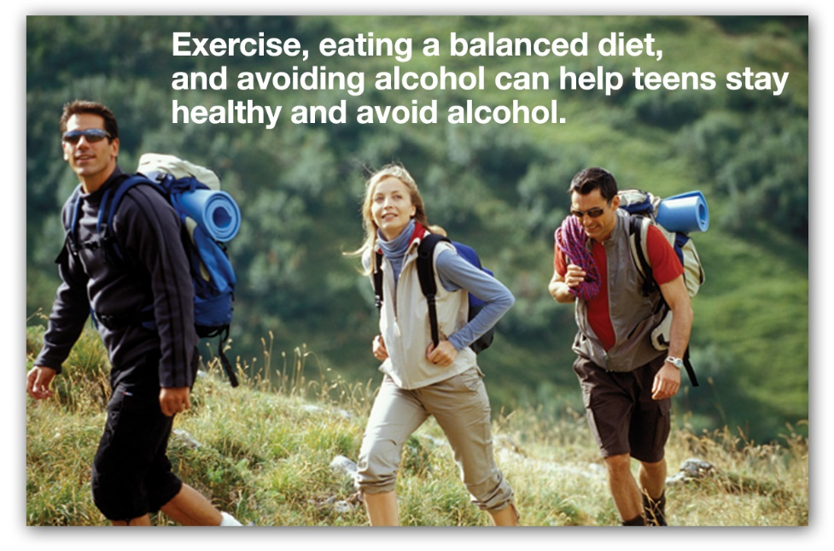
Benefits of Living Alcohol-Free
- Maintaining a healthy body.
- Establishing healthy relationships.
- Making healthy decisions.
- Avoiding risky behaviors
- Avoiding illegal activities
- Avoiding violence.
- Achieving your goals.

Refusing Alcohol
Tips for Alcohol
    - Be assertive and use refusal skills.
    - Call your parents or another trusted adult for a ride home, if needed.
    - Plan alcohol-free activities with friends.
    - Avoid parties or social gatherings where alcohol is served.

Your to avoid alcohol is influenced by the people around you.

