THE IMPACT OF ALCOHOL ABUSE
Chapter 21, Section 3
GLENCOE HEALTH (2011)

BIG IDEA:
Problem drinking and alcoholism both the drinkers and the people around them.
NEW VOCAB:
- blood alcohol concentration (BAC)
- fetal alcohol syndrome (FAS)
- alcoholic
- recovery
- sobriety

Alcohol and Driving
Drinking and driving is very .
Driving while intoxicated (DWI), or driving under the influence (DUI), is
Blood alcohol concentration (BAC) depends on the and type of alcohol that was consumed, the rate of , and body size and gender.
The amount of alcohol in a person’s blood, expressed as a percentage

Any amount of alcohol in the blood can cause the following:
1.
2. Reduced ability to judge distances and speeds
3.
4. Reduced concentration and increased forgetfulness

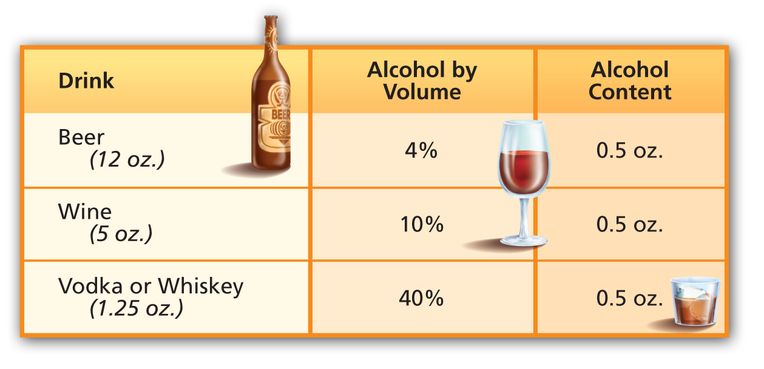

Driving While Intoxicated
Adult drivers who have a BAC of percent can be charged with drunk driving.
For those under , there is no acceptable BAC, since it’s illegal to use alcohol.

Consequences of DWI or DUI
  - Injuries to or death of the driver and others.
  - Arrest, jail time, court appearance and fine or bail, a police record, and possible lawsuits.
  - Severely restricted driving privileges and/or immediate confiscation of driver’s license.
  - Higher auto insurance rates or a canceled insurance policy.

Riding in a vehicle with a driver who has been is just as dangerous as if you were the one drinking and driving.
If someone you’re with has been drinking, find a ride with someone who has not been drinking, or call for a ride.

Alcohol and Pregnancy
A female who drinks during can harm her fetus.
When a pregnant female drinks, alcohol passes directly from her body into the bloodstream of the
Infants born to mothers who drink during pregnancy are at risk of fetal alcohol syndrome (FAS).
A group of alcohol-related birth defects that include physical and mental problems

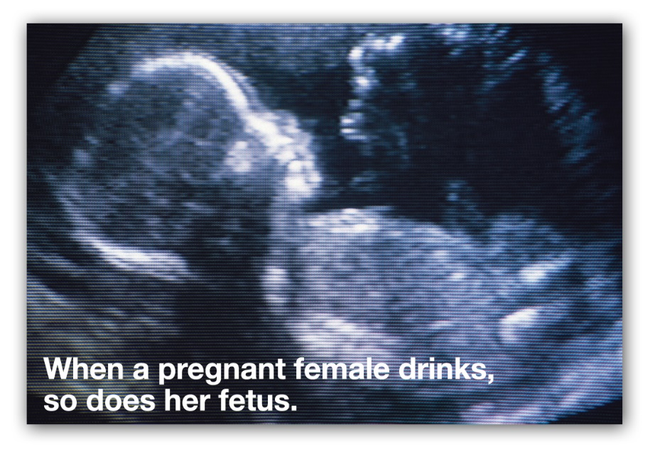

Infants born with FAS may have the following problems:
- Small head and deformities of face, hands, or feet
- Heart, liver, and kidney defects
- Vision and hearing problems
- Central nervous system problems, developmental disabilities, and poor coordination
- Difficulties learning and short attention span
- Hyperactivity, anxiety, and social withdrawal

Alcoholism
Alcoholism is a that affects the person who drinks and others around him or her.
Alcoholics are or dependent on alcohol.
A strong need for alcohol to manage tension or stress, and a preoccupation with alcohol
Inability to limit alcohol consumption
Withdrawal symptoms, such as nausea, sweating, shakiness, and anxiety
A need to drink increasingly more alcohol in order to feel its effects

Alcoholics
The behavior of alcoholics varies—some are aggressive and violent, while others may become
An who is dependent on alcohol

Factors that Contribute to Alcoholism

Stages of Alcoholism
- Abuse 2. Dependence 3.

Alcohol causes serious damage to the liver.

Effects on Family and Society
Alcohol abuse plays a role in crimes and has effects on people who are around problem drinkers.
About percent of violent crimes are alcohol related.
Often, people close to alcoholics develop c behaviors.
Codependents their own needs and instead focus their energy and emotions on the needs of the alcoholic.

Treatment for Alcohol Abuse
Alcoholics can recover if they get t .
Alcoholism be cured, but it can be treated.
When an alcoholic decides to quit drinking, he or she must go through .
The process of learning to live an alcohol-free life
Recovering alcoholics must make a commitment to sobriety.
Living without alcohol

Admitting that alcohol use is a problem
Detoxification, or adjusting to functioning without alcohol
Receiving counseling to change behaviors
Recovery, or taking responsibility for one’s own life

Resources and Programs to Help Alcoholics, their Families and Friends
- Al-Anon/Alateen
- Alcoholics Anonymous
- Mothers Against Drunk Driving (MADD)
- National Association for Children of Alcoholics
- National Drug and Alcohol Treatment Referral Routing Service
- Students Against Destructive Decisions (SADD)
- SAMSHA’s National Clearinghouse for Alcohol and Drug Information

