THE HEALTH RISKS OF DRUG USE
Chapter 22, Section 1
GLENCOE HEALTH (2011)

BIG IDEA:
Drug misuse and substance abuse are life-threatening behaviors.

NEW VOCAB:
- substance abuse
- illegal drugs
- illicit drug
- overdose
- addiction

Substance Abuse
Substance abuse includes the use of substances, as well as the misuse of legal substances.
Medicines can be used in an improper way or intentionally abused.
Substance includes the overuse, or multiple use of a drug, use of an illegal drug, or use of a drug with alcohol.
Any unnecessary or improper use of chemical substances for non-medical purposes

Substance abuse includes:
- of a drug
- use of a drug
- Use of an drug
- Use of a drug with
Some abused substances are illegal drugs.
Chemical substances that people of any age may not lawfully manufacture, possess, buy, or sell
Illicit drug use includes the sale of drugs to those for whom the drugs are not intended.
The use or sale of any substance that is illegal or otherwise not permitted

Factors That Influence Teens
1. Peer Pressure
2. Family Members
3.
4. Media Messages
5. Perceptions of Drug Behavior
6.

can influence you to avoid drugs.

How Drugs Affect Your Health
Illegal drug use can lead to
Substance abuse is a cause of crime, suicide, and unintentional injuries.
Abusing drugs puts you at risk of an overdose or of contracting infectious diseases such as and
A strong, sometimes fatal reaction to taking a large amount of a drug

drugs affects your mental health by impairing your ability to reason and think.
The influence of illegal drug use may cause teens to behave in ways that go against their
Abusing drugs affects your social health in these and other ways:
  - Teens who use drugs may lose friendships with teens who choose to live drug-free.
  - Relationships with family members may suffer.

Other Effects of Drug Use
People who abuse drugs can develop .
This is a condition in which the body becomes to the drug and causes the user to experience a need for more and more of the drug to achieve the desired effect.
A drug abuser believes that a drug is needed in order to feel good or to function normally.
: A drug abuser develops a chemical need for a drug and experiences symptoms of withdrawal when the effects of the drug wear off.
A person with an addiction is someone who requires persistent, compulsive use of a substance known by the user to be harmful.
A physiological or psychological dependence on a drug

A user takes a drug to experience short-term pleasure.

THE ADDICTION CYCLE

As the effects of
the drug wear off, the user then experiences symptoms of withdrawal.
The user takes
the drug again to
relieve withdrawal symptoms and
repeat the feelings of
short-term pleasure.

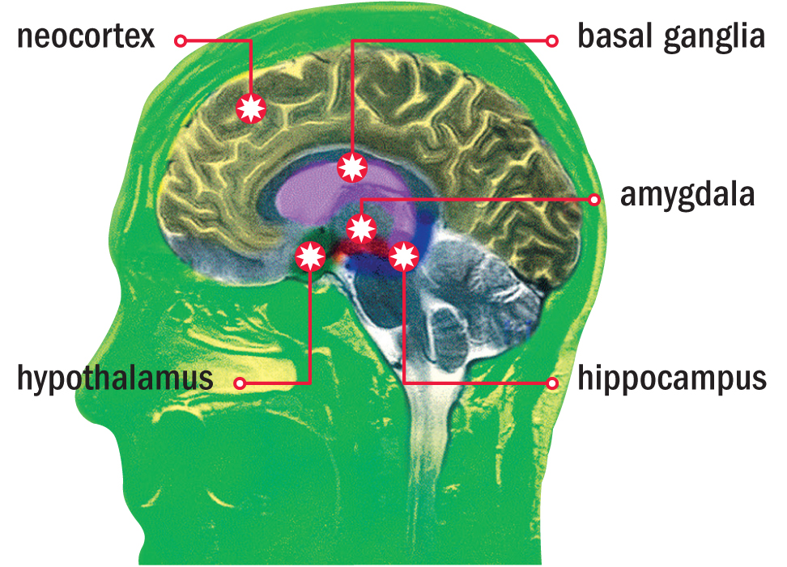
Drug use leads to changes in thinking and the lowering of inhibitions.

Drugs Take a Heavy Toll
In addition to the physical risks to a person’s health, substance abuse can all aspects of your life.
Drug use can create problems that affect a user’s physical, mental/emotional, and social health.
Consequences for the Individual
Teens who use illegal drugs may
- stop pursuing interests and goals.
- engage in dangerous behaviors.
- engage in sexual activity.
- act recklessly.
- be depressed.
- be at risk of suicide.
- be involved in violence or crime.
- be arrested.
Consequences for the Individual
- Some states suspend the driving privileges of minors convicted of a drug offense.
Consequences for Friends and Family
- Teens who use illegal drugs may stop spending time with friends who value a lifestyle.
- Family members who feel for their loved ones feel the burden of the emotional and financial costs of drug abuse.
Consequences for Others
    - If a pregnant female takes drugs, those drugs are to the fetus.
    - The fetus may be born with birth defects, behavioral problems, or a drug addiction.
Consequences for Society
    - Illegal drug use can result in a rise in drug-related crime and .
    - Driving while intoxicated (DWI) or driving under the influence (DUI) can result in collisions that cause and .
    - The consequences of drug abuse—mental, emotional, physical, legal, and social—are 100 percent .
    - By choosing a drug-free lifestyle, you avoid these

