PSYCHOACTIVE DRUGS
Chapter 22, Section 3
GLENCOE HEALTH (2011)

BIG IDEA:
Psychoactive drugs affect the central nervous system and can be especially to the developing brain and body of a teen.

NEW VOCAB:
- psychoactive drugs
- designer drugs
- hallucinogens
- euphoria
- depressants
- stimulants
- opiates

Effects of Psychoactive Drugs
Psychoactive drugs change the of the central nervous system.
The effects on a teen’s developing and can be especially damaging.
Psychoactive drugs change the functioning of the .
Chemicals that affect the central nervous system and alter activity in the brain

Four Main Groups of Psychoactive Drugs
- Stimulants
- Depressants
- Opiates
- Hallucinogens
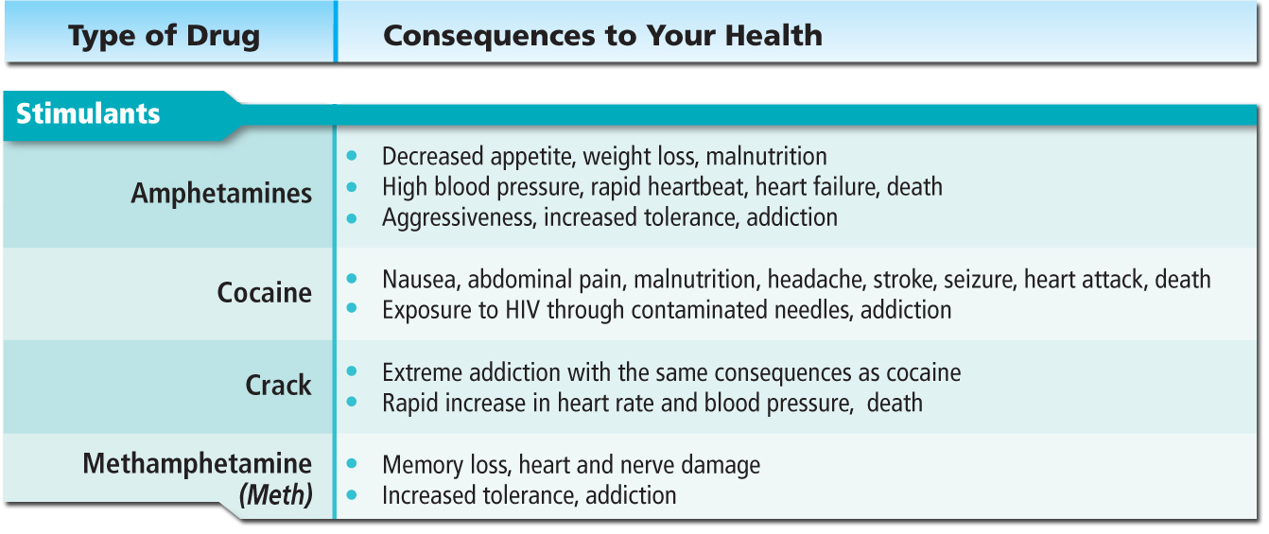

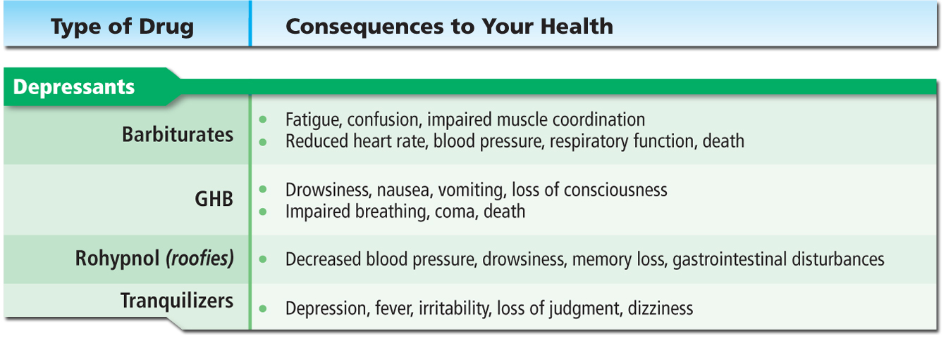

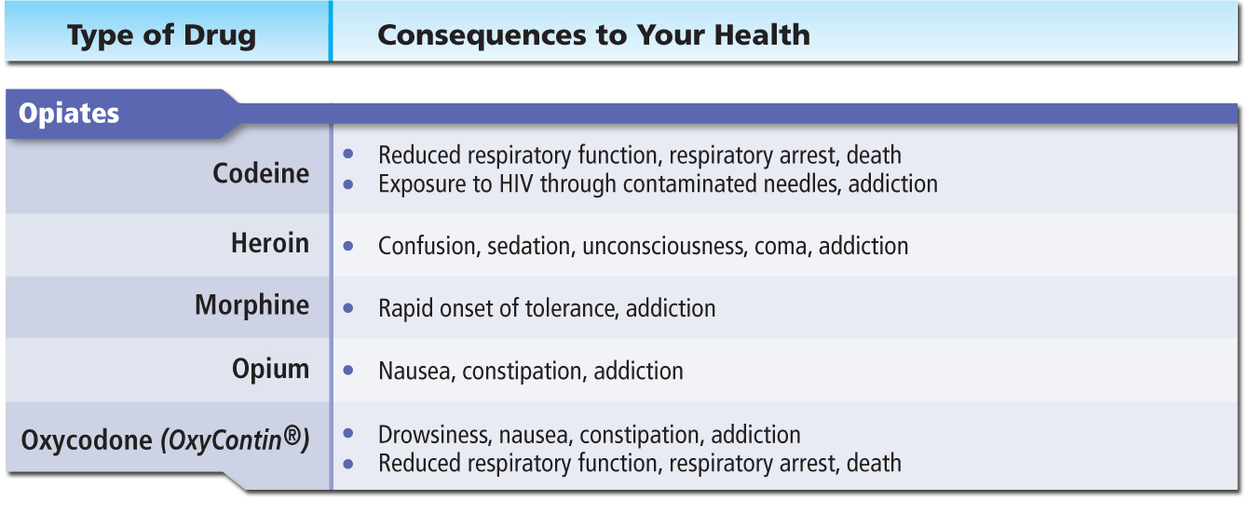

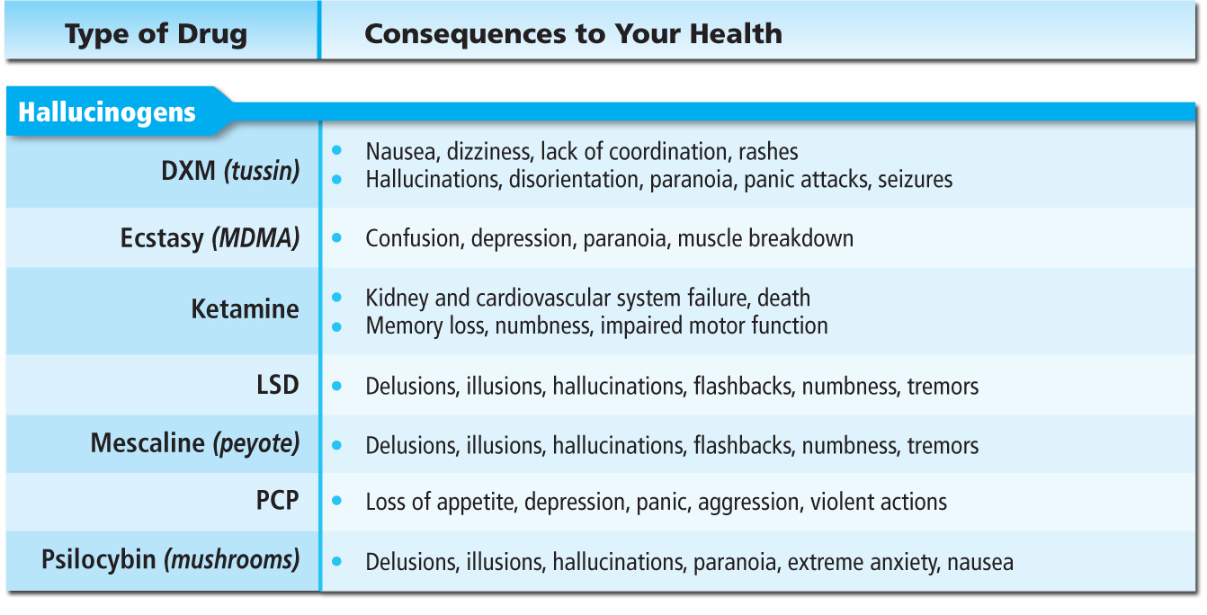

Consequences of Psychoactive Drug Use
Psychoactive drug use can result in health problems and .
Using psychoactive drugs often leads to poor and , which may put teens at risk for unintentional injuries, violence, STDs, unintended pregnancy, and suicide.

Club Drugs, Stimulants, and Depressants
Club drugs, stimulants, and depressants can cause health damage.
Certain drugs are by their effects. They may speed up or slow down the senses, or affect judgment.

Club Drugs
- The term club drug describes drugs found at concerts, dance clubs, and drug parties, called raves.
- These drugs are sometimes disguised in foods, or slipped into drinks and taken without a person’s knowledge.
- Many club drugs are designer drugs
- : Synthetic drugs that are made to imitate the effects of other drugs
Ecstasy (MDMA)
Drugs that alter moods, thoughts, and sense perceptions, including vision, hearing, smell, and touch
Ecstasy may cause short-term euphoria.

Rohypnol
A feeling of intense well-being or elation
Rohypnol, or “roofies,” are depressants, or sedatives that are colorless, odorless, and tasteless.
Drugs that tend to slow the central nervous system
Rohypnol is called the “date-rape” drug.
Engaging in sexual activity with a person under the influence of a date-rape drug is a criminal offense.
Never allow a stranger to handle your drink at a social event.

GHB
GHB, or gamma hydroxybutyric acid, is another CNS
Like Rohypnol, it can be used as a drug.

Ketamine
Ketamine is an anesthetic used to animals.
It causes and may result in respiratory

Meth
Methamphetamine, or meth, is a stimulant.
A drug that increases the action of the central nervous system, the heart, and other organs
Meth takes a great physical toll and can cause depression, paranoia, delusions, and death.

LSD (Acid)
Acid, or lysergic acid diethylamide (LSD), can cause hallucinations and severely distorted perceptions of sound and color.
Flashbacks—states in which a drug user experiences the emotional effects of a drug long after its actual use—can also occur.

Other Stimulants
The in tobacco products is a highly effective stimulant.
The in coffee, tea, cola, and power drinks are all stimulants.

Cocaine
Cocaine is a rapidly acting, powerful and highly stimulant.
Users may experience a surge of self-confidence and euphoria followed by an emotional
Crack
Crack, also called rock or freebase rock, reaches the brain seconds after being smoked or injected.
Once in the blood, crack causes the heart rate and blood pressure to soar to levels.
Amphetamines
Amphetamines are highly addictive drugs that some people use to stay alert, improve athletic performance, or lose weight.
Regular use can result in an irregular heartbeat, paranoia, aggressive behavior, and heart failure.

Other Depressants
Depressants are drugs that tend to the central nervous system.
Depressants are dangerous because they can slow heart and respiration rates and lower blood pressure.
is a commonly used depressant.
Combining small amounts of depressants can cause shallow breathing, weak or rapid pulse, coma, and death.

Barbiturates
Barbiturates are that can cause feelings of intoxication, mood changes, excessive sleepiness, and coma.
Combining barbiturates with alcohol can be

Tranquilizers
Tranquilizers are depressants that relieve anxiety, muscle spasms, sleeplessness, and nervousness.
When tranquilizers are , they can cause physiological and psychological dependence, coma, and death.

Hallucinogens and Opiates
Hallucinogens and opiates seriously alter the sensory controls in the brain.
Hallucinogens overload the brain’s sensory controls. Opiates, which are highly addictive, cause confusion and dull the senses.
Users of hallucinogens experience hallucinations and can also experience flashbacks, or states in which they feel emotional effects of a drug long after its actual use.
Users of hallucinogens sometimes harm themselves physically, or behave violently and harm others.

Powerful and Dangerous Hallucinogens
- Mescaline (peyote
- Ecstasy
- Ketamine
- Acid (LSD)
- Phencyclidine (PCP or angel dust)
- Dextromethorphan (DXM)
- Psilocybin (mushrooms)

PCP
PCP, or angel dust, is one of the most of all drugs, and its effects vary greatly from user to user.
The drug creates a distorted sense of time, increased muscle strength, increased feelings of violence, and the inability to feel pain.
DXM
DXM, or “tussin,” is a cough suppressant sold as an medicine.
When misused, it can cause hallucinations, paranoia, panic attacks, nausea, increased heart rate and blood pressure, seizures, and addiction.

Mushrooms and Peyote
Psilocybin (mushrooms) and mescaline (peyote cactus) are found in nature as a fungus and a plant.
When eaten, they cause hallucinations, nausea, and flashbacks.

Opiates
Abusing opiates dulls the senses, causes drowsiness, constipation, slow and shallow breathing, convulsions, coma, and death.
Drugs such as those derived from the opium plant that are obtainable only by and are used to relieve pain

Codeine
Codeine is a highly addictive ingredient in some prescription medicines.
Codeine use can cause drowsiness, dizziness, labored breathing, low blood pressure, seizures, and respiratory arrest.

Morphine
Morphine is sometimes prescribed to treat severe pain, but is generally used for only a short time.
Side effects include fast or slow heartbeat, seizures, hallucinations, blurred vision, rashes, and difficulty swallowing.
Heroin
Heroin is a processed form of morphine that is injected, snorted, or smoked.
Heroin slows breathing and pulse rate and can cause infection of the heart lining and valves, liver disease, coma, or death.

Oxycodone
Oxycodone contains a strong opiate. It is often referred to by the brand name OxyContin®.
A side effect of this drug is of the respiratory system, which cause death from respiratory failure.

