LIVING DRUG FREE
Chapter 22, Section 4
GLENCOE HEALTH (2011)

BIG IDEA:
By deciding not to use drugs, you promote your own health and influence others to do the same.
NEW VOCAB:
- drug-free school zones
- drug watches
- rehabilitation

Resisting Pressure to Use Drugs
Most teens never experiment with illegal drugs.
By deciding not to use drugs, you protect your health, and become a role model to others.
Most teens never experiment with illegal drugs.
  - 62 percent of high school students have never tried marijuana.
  - 90 percent have never tried cocaine.

Committing to Be Drug-Free

Healthy Alternatives

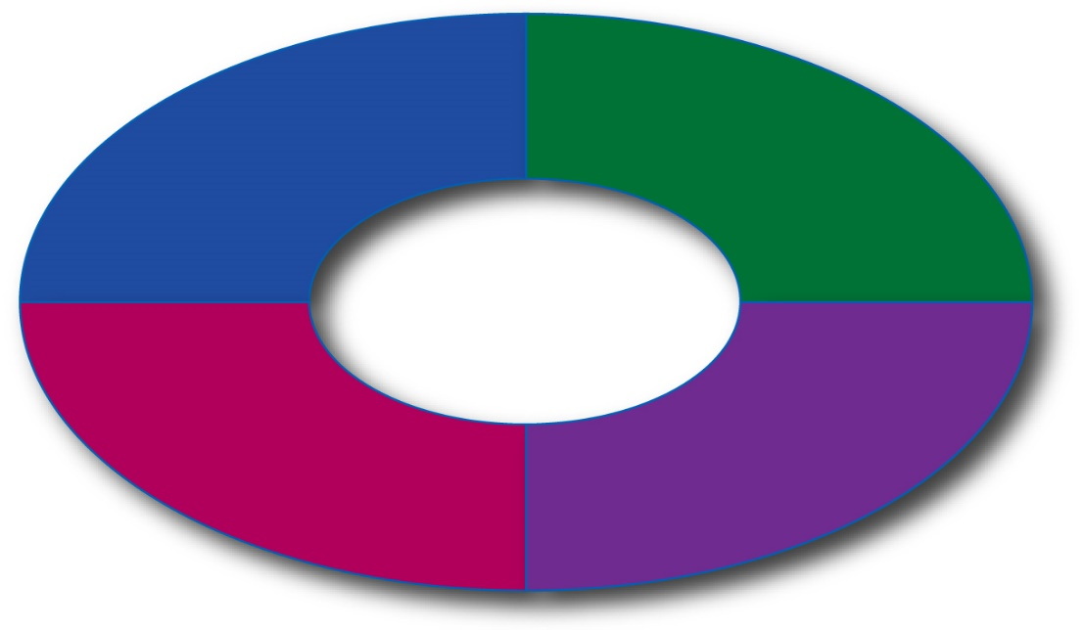

Drug Prevention Efforts
Schools and communities are working together to support students in their efforts to be drug-free.
Everyone can help reduce substance abuse by committing to remain drug-free.

School Efforts
Near schools, drug-free school zones have been established.
Areas within 1,000 to 1,500 feet of schools and designated by signs, within which people caught selling drugs receive especially severe penalties

The penalties for using, selling, or possessing drugs in a drug-free school zone are often double what they might be for the same drug offense committed elsewhere.

Examples:
1.
2.
3.
4.
5.

Community Efforts
Communities across the nation are organizing anti-drug programs and drug watches to take action to prevent drug abuse.
Organized community efforts by neighborhood residents to patrol, monitor, report, and otherwise try to stop drug deals and drug abuse

Becoming Drug-Free
Many types of counseling are available for those who want to become drug-free.
Once someone begins using drugs, addiction can occur rapidly.
The following steps can guide you in helping a friend or family member:
- Identify sources of help in your community
- Talk to the person when he or she is sober.
- Express your affection and concern.
- Describe the person’s behavior without being judgmental.
- Listen to the person’s response.
- Be prepared for anger and denial.
- Offer to go with your friend or family member to a counselor or support group.

The following behaviors may indicate that a person has a drug problem:
- Lies about the drugs he or she is using, constantly talks about drugs
- Stops participating in activities that once were an important part of his or her life
- Changes eating or sleeping habits, shows rapid weight loss
- Takes unnecessary risks, participates in unsafe behaviors
- Gets in trouble with authorities, such as school administrators or police
- Seems withdrawn, depressed, tired, and cares less about appearance
- Has red-rimmed eyes and runny nose not related to colds or allergies
- Has blackouts and forgets what he or she did under the influence
- Has difficulty concentrating

Getting Help
The process of medical and psychological treatment for physiological or psychological dependence on a drug or alcohol
Drug treatment centers offer a safe place to withdraw from drug use.
Many of these centers provide medications to help with the physical and psychological effects of withdrawal.
Types of Drug Treatment Centers:
These programs usually do not include medications and often use individual or group counseling.
These centers can include residential therapy, medication therapy, and outpatient therapy.
Intended for heroin addicts, this treatment usually includes medication therapy.
These are residences for drug abusers. The centers include highly structured programs that may last from six to 12 months.

