DEVELOPING YOUR SELF-ESTEEM
CH 3, Part 1
From GLENCOE HEALTH (2011)

BIG IDEA: Good mental and emotional health helps you develop healthy self-esteem.

NEW VOCAB:
- mental/emotional health: __________________________________________________________________________________________________________________________________________________________________________________________________
- resilient: __________________________________________________________________________________________________________________________________________________________________________________________________
- self-esteem: __________________________________________________________________________________________________________________________________________________________________________________________________
- competence: __________________________________________________________________________________________________________________________________________________________________________________________________
- hierarchy of needs: __________________________________________________________________________________________________________________________________________________________________________________________________
- self-actualization: __________________________________________________________________________________________________________________________________________________________________________________________________
What is Mental and Emotional Health?
_________________________ and _________________________ health helps you _________________________ effectively each _________________________.
Do you see yourself in a _________________________ way? Are you able to handle _________________________ and setbacks well? These are _________________________ of mental and emotional health.
Having good mental/emotional health is an _________________________ part of your total _________________________.

The Importance of Mental and Emotional Health
Mentally healthy people are, in general:
_________________________ , _________________________ , comfortable spending time alone or with others, _________________________ , able to cope with a wide variety of feelings and situations.

Characteristics of Good Mental and Emotional Health
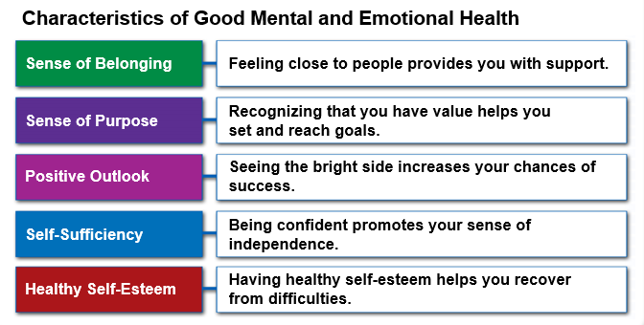

Mentally and emotionally _________________________ people are _________________________.
Close friends _________________________ one another.

Self-Esteem
Healthy self-esteem is _________________________ for good mental/emotional _________________________.
Having good self-esteem affects your overall _________________________ and the health choices you make.
Self-esteem _________________________ the other characteristics of good _________________________ health.
Trying new _________________________ can raise your sense of _________________________.
How You Develop Self-Esteem
_________________________, the encouragement or _________________________ that you give _________________________, can affect your self-esteem.
Replace _________________________ thoughts with _________________________ self-talk to _________________________ your self-esteem.

Benefits of Healthy Self-Esteem
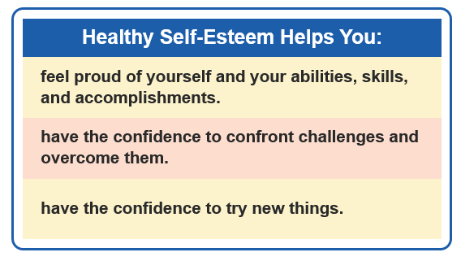
Improving Your Self-Esteem
You can _________________________ your self-esteem and your overall _________________________ and _________________________ health.
You can _________________________ many things that _________________________ your self-esteem.
Suggestions for Improving Your Self-Esteem.
- Choose _________________________ who _________________________ and respect you.
- Focus on _________________________ aspects about _________________________.
- Replace _________________________ self-talk with _________________________ self-talk.
- Work toward __________________________________ rather than _________________________.
- Consider your mistakes _________________________ opportunities.
- Try new _________________________ to discover your _________________________.
- Write down your _________________________ and the ___________________ to achieving them.
- _________________________ regularly to feel more _________________________.
- _________________________ your time to _________________________ someone.
- _________________________ the things you can’t _________________________.
- Focus your _________________________ on changing the things you can _________________________.
Developing Self-Awareness
Understanding your _________________________ and meeting them in _________________________ ways will help you reach your highest _________________________.
As _________________________, we rely on others to meet our basic needs. As we _________________________, our needs become more _________________________.
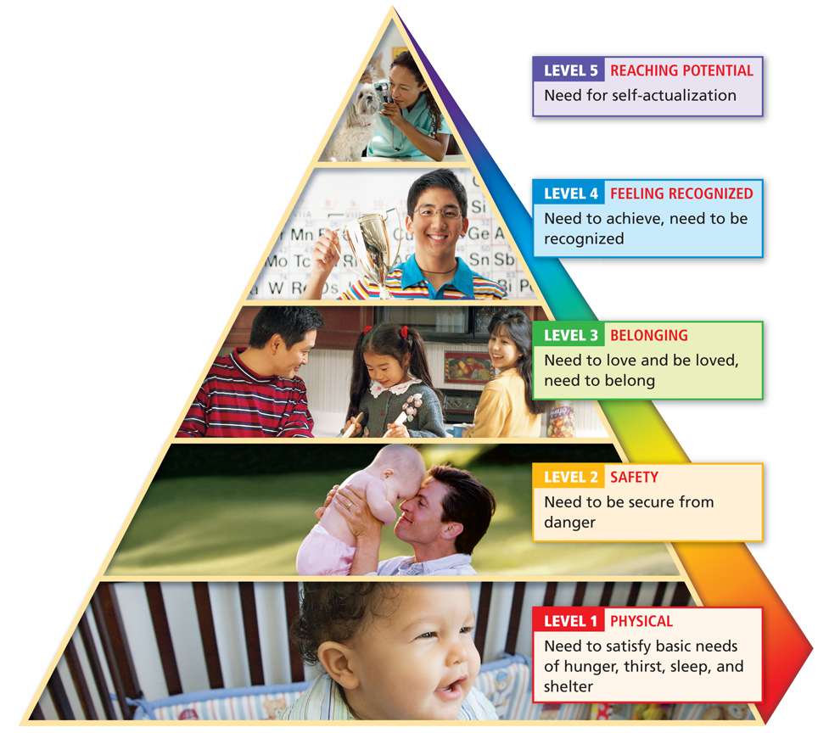
Maslow’s hierarchy shows that once our basic _________________________ and _________________________ needs are met, we become interested in meeting these needs:
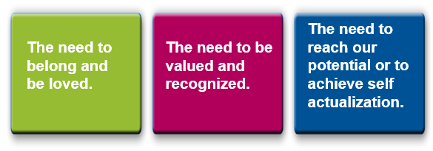

The _________________________ level of Maslow’s hierarchy is _________________________ potential, or _________________________ self-actualization.
As your self-awareness grows, you can begin to take more _________________________ of your personal growth.
Reaching out to others can help you grow by developing deeper _________________________ and a _________________________ support group.

