DEVELOPING YOUR SELF-ESTEEM
CH 3, Part 2
From GLENCOE HEALTH (2011)
BIG IDEA: Healthy identity is based on being a person of good character.
NEW VOCAB:
- personal identity: _________________________________________________________________________________________________
- role model: _________________________________________________________________________________________________
- personality: _________________________________________________________________________________________________
- character: _________________________________________________________________________________________________
- integrity: _________________________________________________________________________________________________
- constructive criticism: _________________________________________________________________________________________________
Your Personal Identity
Your _______________________ _______________________ describes who you _______________________.
Identity _______________________ is one of the most important tasks you will _______________________ during your _______________________ years.
Your _______________________ _______________________ depends a lot on your _______________________ and _______________________.
How Identity Forms
Influences on Personal Identity:
_______________________ and _______________________ , _______________________ , _______________________ , _______________________ , _______________________ , _______________________ , _______________________ ,
_______________________ Goals,
_______________________ Experiences
You may identify a _______________________ who you _______________________ up to and want to be like.

Aspects of Identity
Your _______________________ sets you apart from other people and _______________________ how you will react in certain _______________________.

The Importance of Good Character
_______________________ plays a significant role in your _______________________, actions, and _______________________.
Good character is an outward _______________________ of inner _______________________ and is a vital part of _______________________ identity.
A person of good _______________________ demonstrates core _______________________ values, such as _______________________, _______________________, and respect.

Traits of Good Character
Six Traits of Good Character
______________________________ , ______________________________ , ______________________________ , ______________________________ , ______________________________ , ______________________________
By demonstrating the _______________________ of good character consistently in your actions and _______________________, you show others that you have _______________________.
_______________________ is a sign of _______________________.

Working Toward a Positive Identity
You can _______________________ a healthy _______________________.
Your _______________________ and your circumstances influence your identity, but as you _______________________, you control who you _______________________.
Tips for Promoting a Healthy Identity
- List your _______________________ and _______________________.
- Surround _______________________ with _______________________, supportive people.
- Find something that you _______________________ to do, and do it _______________________.
- Stop making life a _______________________.
- _______________________ someone _______________________.

Recognize Your Strengths and Weaknesses
To begin to understand your identity:
- _______________________ your _______________________ and _______________________.
- Be _______________________ of yourself and your _______________________.
- Be _______________________ of your _______________________ and set realistic _______________________ to improve.
Demonstrate Positive Values
Practicing good _______________________ is not always easy, but it helps you build a positive _______________________.
Take actions that demonstrate positive values to build _______________________ and a positive _______________________.

Develop a Purpose in Your Life
A sense of _______________________ helps you set _______________________ and work to achieve them.
A sense of purpose also provides you with a _______________________ to build a healthy identity
Form Meaningful Relationships
Relationships provide a support system that can help you build _______________________ and develop a sense of _______________________ and _______________________.
Within a meaningful relationship, _______________________, friends or others may give you constructive _______________________.

Avoid Unhealthful High-Risk Behaviors
Take healthful _______________________ that challenge you to _______________________ skills and to _______________________ in new ways.
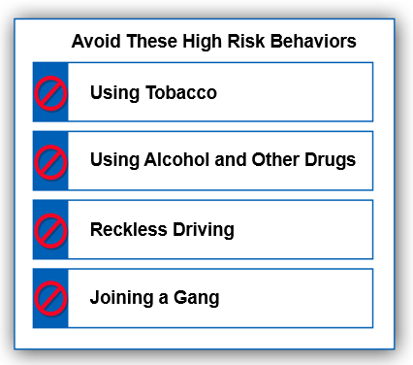
Contribute to the Community
Your community is your extended _______________________ system. It provides _______________________ and resources to meet many of your _______________________.

