DEVELOPING YOUR SELF-ESTEEM
CH 3, Part 3
From GLENCOE HEALTH (2011)
BIG IDEA: Managing your emotions allows you to express them in healthful ways.
NEW VOCAB:
- Emotions: _________________________________________________________________________________________________
- Hormones: _________________________________________________________________________________________________
- Hostility: _________________________________________________________________________________________________
- Empathy: _________________________________________________________________________________________________
- defense mechanisms: _________________________________________________________________________________________________
Understanding Your Emotions
________________________ and acknowledging your ________________________ is a sign of good ________________________ and ________________________ health.
How you ________________________ to your ________________________ can affect your mental/emotional, physical, and social health.
Learning to ________________________ your emotions and to understand their ________________________ on you will help you learn to manage them in healthful ways.
Changes during ________________________ are caused by ________________________.
________________________ can make you feel as if your emotions are swinging from one ________________________ to another.
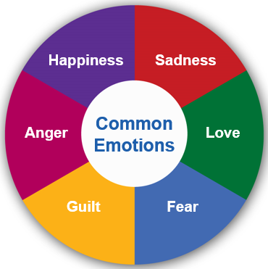
Understanding Your Emotions
________________________ is a form of anger that can hurt others, as well as the hostile person.
Managing Your Emotions
Knowing how to recognize your emotions can help you ________________________ them in healthful ways.
Learning to ________________________ emotions in a healthful way will not only help you ________________________ with emotional ________________________, but also helps those around you to better handle their ________________________.
Dealing with Emotions in Positive Ways
________________________ are neither good nor ________________________.
The way you ________________________ your emotions, however, can produce ________________________ or bad ________________________.
Feeling bad, or ________________________, when things happen in your life is ________________________.
These feelings can be ________________________.
One example of expressing ________________________ is supporting a ________________________ who is going through a ________________________ time.
To help you recognize your ________________________ and ________________________ them in positive ways, ask yourself these questions:
- Why do I ________________________ the way I do about this ________________________?
- Will this event matter ________________________ on in my ________________________?
- Why should I wait before responding?
- What can I do to ________________________ better?
- Who can I ask to help me ________________________ with my ________________________ feelings?
Healthful expression of feelings lets you ________________________ life more.
Responding to Difficult Emotions
Reducing the ________________________ of ________________________
- Take several deep ________________________.
- ________________________ your muscles.
- Get away from the ________________________ until you calm down.
- Analyze your ________________________ by writing about them in a private journal.
Sometimes you may use ________________________ mechanisms unconsciously as a way to ________________________ yourself from intense ________________________ pain.
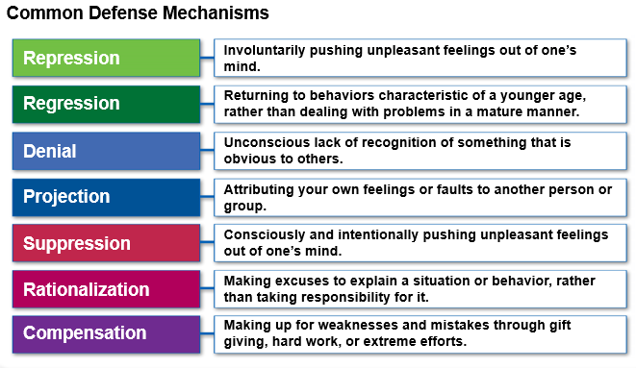

Handling Fear
You can overcome some ________________________ by recognizing that you’re afraid and figuring out what is causing this ________________________.
If you’re unable to ________________________ your fears, consider seeking the help of a ______________________________________ professional.

Dealing with Guilt
________________________ is a very destructive emotion that can ________________________ your self-esteem.
If you feel ________________________ about something:
- Look at the circumstances ________________________ and ________________________.
- Admitting a ________________________ can help manage feelings of ________________________.
- Sometimes you will feel guilt about situations that are out of your ________________________.

Managing Anger
________________________ is one of the most difficult ________________________ to handle.
As with guilt, it is best to figure out what is causing your anger, and then ________________________ with it in a ________________________ way.
When you first feel anger building up inside you, try to _____________________________________.
If this doesn’t work, physically ________________________ yourself from the ________________________.
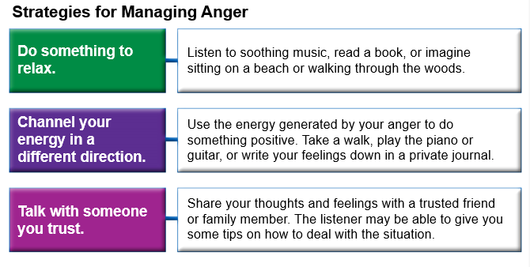
________________________ ________________________ is a healthy way to use the energy that can build up from ________________________.

