UNDERSTANDING STRESS
CHAPTER 4, SECTION 1
GLENCOE HEALTH (2011)

BIG IDEA: Stress can affect you in both positive and negative ways.

NEW VOCAB:
- stress
- perception
- stressor
- psychosomatic response

How you think about a challenge determines whether you will experience or stress.
Feeling is a natural part of life. Stress is the reaction of the body and mind to everyday and demands.

What is Stress?
How much the stress of an event you, however, depends in part on your of it.
The act of becoming aware through the senses

Stress can have both a positive and a negative .
stress can motivate you and inspire you to work harder.
stress can cause you to feel distracted, overwhelmed, impatient, frustrated, or even angry. It can harm your health.

vary among individuals and groups.
, , places, events, and are all potential stressors.

The effect of a stressor depends on your and perceptions.
Anything that causes stress

Stressors activate the and specific .
When you perceive something to be dangerous, difficult, or painful, your body begins a stress response.

The stress response involves stages.
- Your mind and body go on high alert. This “fight-or-flight” response prepares you to defend yourself or to flee from a threat.
-If exposure to a stressor continues, your body adapts and reacts to the stressor. This stage lasts for a brief period.
-If exposure to stress is prolonged, you begin to tire and lose the ability to manage other stressors effectively.

- Alarm begins when the , a small area at the base of the brain, receives danger signals from other parts of the brain. The hypothalamus releases a hormone that acts on the pituitary gland.
- The gland secretes a hormone that stimulates the adrenal glands.
- The adrenal glands secrete adrenaline. is the “emergency hormone” that prepares the body to respond to a stressor.

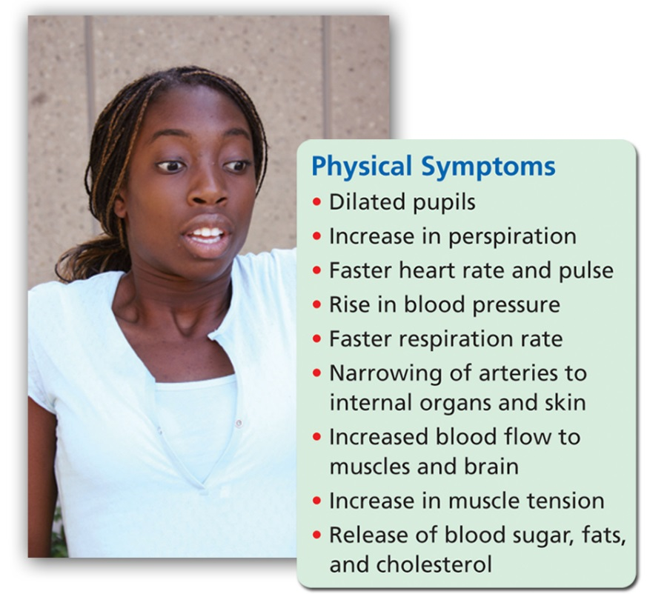

Ongoing stress affects aspects of your health.
The changes that take place in your body during the stress response can take a toll on your body.

Prolonged stress can lead to a response.
-A physical reaction that results from stress rather than from an injury or illness

The Physical Effects of Stress

Mental/Emotional and Social Effects of Stress

