MANAGING STRESS
Chapter 4, Section 2
GLENCOE HEALTH (2011)

BIG IDEA:
You can manage by learning skills to reduce the amount and impact of stress in your life.

NEW VOCAB:
- chronic stress
- stress-management skills
- relaxation response
- resilient

Identifying what is is the first step in learning how to manage stress.
The trick for managing stress is to learn to keep stress from building up and to deal with stressors effectively.

When Stress Becomes a Problem
The effects of stress are , meaning they build up over time. An increasing number of teens are experiencing chronic stress.
-Stress associated with long-term problems that are beyond a person’s control

Stress-Management Techniques
You can develop strategies to both and stress
- skills help you manage stressors in a healthful, effective way.

Avoiding and Limiting Stress
situations that cause stress is the easiest way to reduce its effects.
If you’re unable to avoid a stressor, you can try to or limit the amount of stress you’re exposed to.

Strategies for Avoiding and Limiting Stress
: If taking on a new activity will add to your stress, use refusal skills to say no.

: Manage your time wisely by planning ahead. Think about how stressed you feel before a test
: A positive outlook limits stress by shifting your perception and how you respond to a stressor.
: Using tobacco, alcohol, and other drugs will harm the body and cause more stress.

Overcoming Test Anxiety
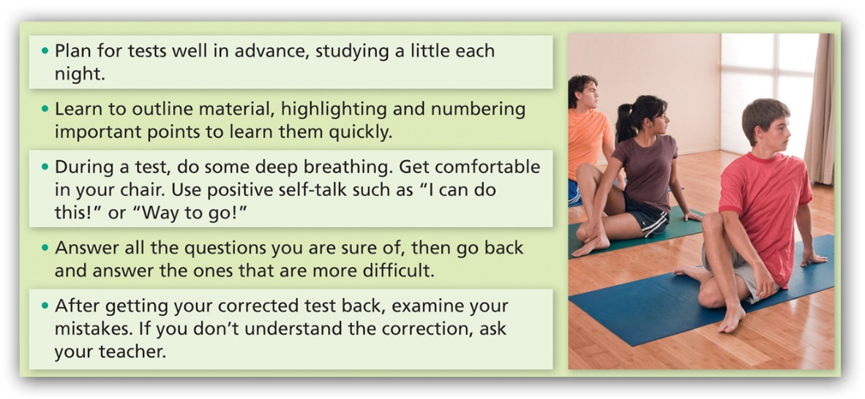

Avoiding and Limiting Stress
ahead can help you avoid or limit stress

Handling Stress and Reducing Its Effects
For stressors that are unavoidable, practice stress reduction techniques to achieve a

A state of calm

To lower the impact of stress on your health, try these tips:
Deep breathing, thinking pleasant thoughts, stretching, taking a warm bath, and even laughing can relieve your stress.
When energy builds up from stress, use that energy in a constructive way. Work on a creative project or engage in physical activity.
Confide in someone you trust for an objective view and valuable advice.

Staying Healthy and Building Resiliency
Taking care of your health is to stress management.
Positive health-maintenance habits help you deal with stress, , reduce stress, and from stress.

Get Adequate Rest
Adequate can help you face the challenges and demands of the next day.
Using - skills will allow you to get the eight to nine hours of sleep that you need each night.

Get Regular Physical Activity
Participating in regular activity benefits your overall health.
Physical activity can release pent-up energy, your mind, your energy level and your endurance, and help you better.

Eat Nutritious Foods
Eating a variety of foods and drinking plenty of water not only helps your body function properly, but it also the effects of stress.
eating habits can contribute to stress, causing weakness, fatigue, and a reduced ability to concentrate.

By including - and - strategies in your daily routine, you can become more resilient.

helps you handle difficulties and challenges in healthful ways and achieve long-term success in spite of negative .

