COPING WITH LOSS AND GRIEF
Chapter 4, Lesson 3
GLENCOE HEALTH (2011)

BIG IDEA:
Understanding the grieving process helps you cope with loss and manage your feelings in healthy ways.

NEW VOCAB:
- stages of grief
- closure
- coping
- mourning
- traumatic event

Acknowledging Loss
a loss is one way to help begin the healing process.
Everyone experiences loss during their lives and the grief that it brings.
is a common and natural reaction to any loss that brings on strong emotions.
Acknowledging and understanding your grief will help you begin the

Expressing Grief
The grieving process can help people the loss and start to heal.
Feelings of loss are very . Everyone grieves in their own way. Some may talk about their loss; others may want to be alone.

The Grieving Process
Swiss-American psychiatrist Elisabeth Kübler-Ross noted that the grieving process includes of grief.
A variety of reactions that may surface as an individual makes sense of how a loss affects him or her

STAGES OF GRIEF
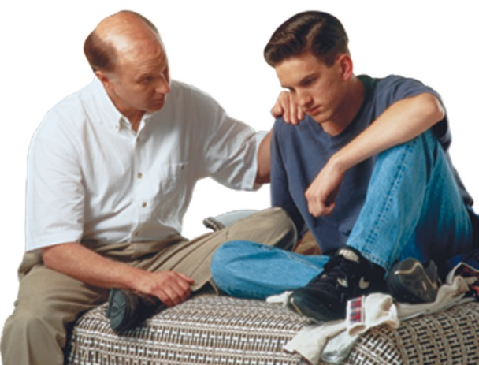

During the or Numbness stage of grief, it may be difficult to believe the loss has occurred.
During the stage of grief, the loss is recognized. This stage often involves periods of crying.
During the stage of grief, the person uses anger because he or she feels powerless and unfairly deprived.
During the stage of grief, the reality of the loss sets in and the person may promise to change if what was lost can be returned.
During the stage of grief, there are feelings of sadness. In addition, feelings of isolation, alienation, and hopelessness may occur
During the stage of grief, the person may become preoccupied with thoughts about how the loss could have been prevented.
During the stage of grief, the person faces the reality of the loss, and experiences closure.
The acceptance of loss

Memorial services and sites help people grieve and show

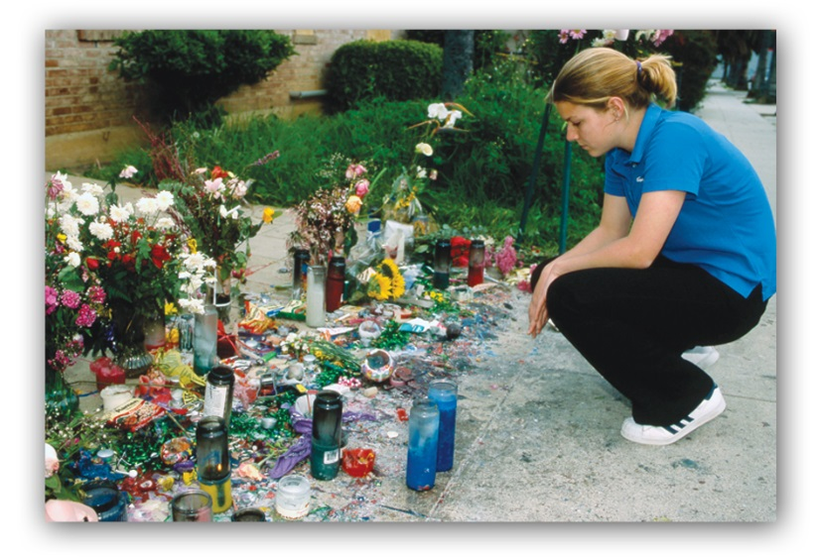

Coping with Death
Coping with death involves and support
is one of the most painful losses we can experience.

Most people respond to loss by
The act of showing sorrow or grief
Mourning includes about the person, the pain of the loss, and searching for .

Showing Empathy
Grieving makes the process more difficult
The and of others who are also grieving may make the process easier.
If you know someone who is grieving, show support by helping the person to happy memories and being a listener.
Use when appropriate.

Community Support
A person’s background also influences grieving.
Common mourning rituals, such as memorial services, wakes, and funerals are events that the life of the person who has died.

Coping with Traumatic Events
Support from family, friends, and community resources can help individuals
from a traumatic event.
Traumatic events are and , such as accidents, violent assaults, suicides, and natural disasters.
After a traumatic event, you may question your sense of and

Any event that has a stressful impact sufficient to overwhelm your normal coping strategies

