FOUNDATIONS OF PERSONAL FITNESS
Glencoe
CHAPTER 2, PART 1

What You Will Do
- Define _____________________________ ________________________________ and identify who needs them.
- Identify the types of ________________________________ gathered during a medical screening.
- Describe the role your ________________________________ ________________________________ plays in your overall levels of ________________________________.

Personal Fitness Screening
At some time, you may have asked yourself these questions:
What is a ________________________________ screening?
What does it have to do with ________________________________?

TERM: Medical Screening ____________________________________________________________________________________________________________________________________________________________________________________________________________________________________

A medical screening measures the individual’s physical ________________________________ to take part in ________________________________ activity.
A medical screening also detects medical ________________________________ that may be aggravated by vigorous ________________________________.
Medical screenings are important to people who have poor ________________________________ ________________________________.
Medical screenings are especially important to people who are ________________________________.
Medical screenings are especially important to people who are ________________________________ or suffer from ________________________________.
________________________________ is a major health problem in the United States today.

TERM: Obesity ____________________________________________________________________________________________________________________________________________________________________________________________________________________________________
Medical screenings are especially important to people who have a known ________________________________ disease such as ________________________________ disease or ________________________________.

TERM: Chronic Disease ____________________________________________________________________________________________________________________________________________________________________________________________________________________________________

________________________________ is a chronic disease that affects a person’s ability to perform ________________________________ demanding activities.

TERM: Asthma ____________________________________________________________________________________________________________________________________________________________________________________________________________________________________
The necessity of a medical screening varies with age.
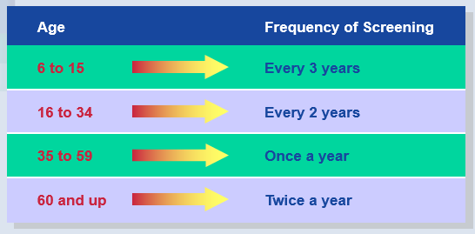

What Happens During a Medical Screening?
A medical screening may consist of the following:
- A complete blood count, or ________________________________
- Your ________________________________ and ________________________________
- An examination of your ______________, ______________, ______________, and ______________
- Your __________________________________________________
- An examination of your ________________________________ and ________________________________
- For males, a test for ________________________________
TERM: Hernia ____________________________________________________________________________________________________________________________________________________________________________________________________________________________________
A medical screening carried out by a physician includes an update of your medical history.

TERM: Medical History ____________________________________________________________________________________________________________________________________________________________________________________________________________________________________

