Foundations of Personal Fitness
Chapter 4, Section 3
What You Will Do
- Identify the __________________________ Guidelines for Americans.
- Identify the role of the Food Guide __________________________ and the __________________________ Facts panel in a healthful eating plan.
- Analyze a __________________________ by calculating its percentage of calories that come from the various food groups.
- Explain how to develop __________________________ eating habits.
- Identify ways to keep food __________________________.

The Foods You Eat
Foods that are __________________________ for you can also __________________________ good.
There are easy-to-use tools that can help you determine if your food choices are nutritious.

Dietary Guideline for Americans:
The Dietary Guidelines for Americans identifies ten guidelines for healthy-eating and living, the ABCs of good health:
A _____________________________________________
B _____________________________________________
C _____________________________________________

- __________________________ for fitness
  - Aim for a healthy __________________________.
  - Be __________________________ active each day.
- Build a healthy __________________________
  - Let the Food Guide __________________________ guide your food choices.
  - Choose a variety of __________________________ daily, especially __________________________ grain.
  - Choose a variety of __________________________ and __________________________ daily.
  - Keep food safe to __________________________.
- Choose __________________________
  - Choose a diet that is low in __________________________ fat and cholesterol and moderate in total __________________________.
  - Choose beverages and foods to moderate your intake of __________________________.
  - Choose and prepare foods with less __________________________.
  - Avoid __________________________ beverages.
The Food Guide Pyramid shows a range of servings for the different food groups you need to eat each day to achieve and maintain good health.

TERM TO KNOW
______________________________________________________ - A visual guide to help make healthful food choices.
The Food Guide Pyramid
The recommendations in the Food Guide Pyramid are based on Dietary Reference Intakes (DRI).

TERM TO KNOW
______________________________________________________ (DRI) - Daily nutrient recommendations for healthy people of both genders and different age groups.

This Pyramid is referred to in the Dietary Guidelines for Americans.
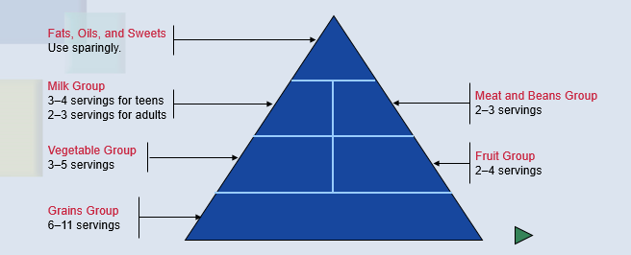

For good nutrition:
- Try to stay within __________________________ ranges for each food __________________________.
- Eat at least the __________________________ number of servings to get enough __________________________.
- Control __________________________ sizes. When you feel full, __________________________ eating.

Nutrition Facts
By reading the __________________________ Facts panel, you can compare different food products, make wise __________________________, and get an idea of what and how much you are consuming.

Nutrition Facts panel - Provides a thumbnail analysis of a food’s __________________________ and __________________________ content for one serving.

Developing Healthful Eating Habits
Good nutrition comes from an eating plan that has __________________________, moderation, and __________________________.

Breakfast is important for these reasons:
Breakfast replenishes your body’s __________________________ supply.
Breakfast improves your __________________________ and __________________________ performance.
Breakfast is important for maintaining a healthy __________________________.
Breakfast may help you avoid __________________________ later in the day.

A healthful eating plan includes nutritious __________________________ that provide extra energy and __________________________.
When choosing __________________________, select whole-grain products, fruits, and vegetables.

Keeping Food Safe to Eat
Handling and preparing food safely will prevent foodborne __________________________.

TERM TO KNOW
_________________________________________ - Illness that results from consuming food contaminated with disease-causing organisms, the __________________________ they produce, or chemical contaminants.

To prevent cross-contamination, wash your hands, __________________________ boards, and countertops with hot, __________________________ water before and after food preparation.

TERM TO KNOW
___________________________________ - The spreading of bacteria or other pathogens from one food to another.

Follow these food safety guidelines to prevent foodborne illnesses:

________________________ ________________________ ________________________ ________________________

