Foundations of Personal Fitness
Chapter 5, Section 3

What You Will Do
- Analyze methods of measuring body .
- Define ranges of healthy body fat for teens.
- Identify that are used in computing body composition.

Terms to Know
- girth
- calipers

Evaluating Your Body Composition
It is important to be aware that every method of measuring body composition is to some degree
If your body fat measurement is for any test, consult a health care professional.

Body Circumference
The body-circumference test measures
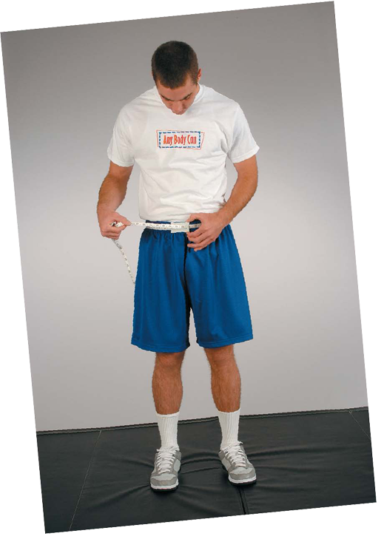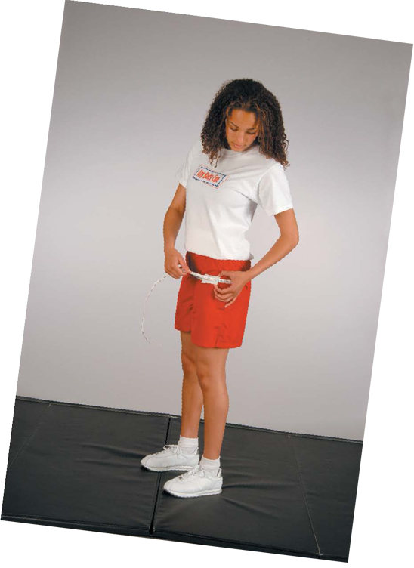

Body fat is stored differently in males and females
    - In males, body fat accumulates around the
    - In females, body fat accumulates around the .

To measure body circumference, males should follow these steps:
- Measure your weight in .
- Measure your girth at the .
- Use the body fat percentage chart on page 160 to determine your percentage of body fat.

To measure body circumference, females should follow these steps:
  - Measure your .
  - Measure the girth of your hips at the point.
  - Use the body fat percentage chart on page 160 to determine your percentage of body fat

Once you have determined your percentage of body fat, you can evaluate your body fat
If you do not score in the - - health zones, in Figure 5.10, page 161, try to improve your body composition.

Skinfold Measures
Another method used to evaluate body composition is skinfold measurement using

